Autopsy table KLT-J650
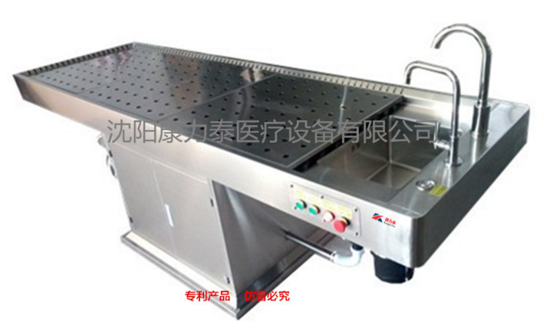
Describe Characteristic

KLT=J650 Forensic anatomical table
Is our company according to the Ministry of Public Security first class demonstration criminal science and technology anatomy room construction to seek the specialized design, the dissection table has the exhaust wind, the anatomy dual function, the whole modelling luxurious atmosphere, uses the stainless steel material to press the forming, the precision production; Acid and alkali resistance. Especially, the harmful odor, blood and water produced during dissection can be extracted from the dissection table, which improves the working conditions of forensic medical personnel, and improves the quality of identification and the level of examination.
Features:
table surface arc connection, no scaling, easy to clean. The dissecting table can be removed as a whole for easy cleaning. The pool is equipped with a body hair isolator to prevent hair from entering the drain pipe. The pool has manual faucet, the temperature of cold and hot water can be adjusted (need to be connected with external water heater), the water pressure of moving spray gun can be adjusted, and the whole sewage exhaust design of the dissecting platform can be made. Dissected open-hole exhaust (need to be connected with external ventilator) to remove harmful gases from the operating process in time. There is a waterproof power outlet on the side of the dissection table. Dissection table, adopt new electric control lifting, stable and reliable maintenance simple, safe and reliable, energy saving and consumption reduction, after-sales service specification, no worry about the square base, fixed type

Size: 2400 * wide 800 * High 850mm
Power supply: ac 220V 50HZ

